**The Convener**

**IEC-NRI Medical College &General Hospital,**

**Chinakakani, Guntur (Dist.), AP.**

Project Title **:**

Department **:**

Place of Study **:**

Purpose of the Study **:**

Principal Investigator **:**

Name **:**

Affiliation **:**

Email **:**

Co-Investigators/ Guide **:**

1. Name **:**

Affiliation **:**

1. Name **:**

Affiliation **:**

Duration of study **:**

Sponsors (if any) **:**

Approval from any other Ethics / Regulatory Committee (if required):

**I shall follow the Good clinical practice guidelines and approved protocol in conducting the research project. Further I/we declare that any sort of inclusion of text or pictorial material which amounts to Plagiarism will be avoided.**

Signature of HOD Signature of the Investigator(s)

Signature of the Guide

**SYNOPSIS**

**Title :**

**Principal Investigator :**

**Department & Institution :**

**Introduction:**

**Aims & Objectives:**

# Methodology:

**Study design:**

**Study setting:**

**Study population:**

**Inclusion criteria:**

**Exclusion criteria:**

**Method of Collection of Data**

**Statistical Analysis**:

**References:**

**STUDY FLOW CHART**

**Title**  **:**

**Principal Investigator** **:**

**Department & Institution :**

Recruitment of the subject & Enrollment

⇩

Selection of patients as per the inclusion-exclusion criteria

⇩

Making study groups

⇩

Study Procedures

⇩

Data collection

⇩

Statistical analysis

⇩

Conclusion

**ID No. ______**

Mobile No: Mobile No:

**INFORMED CONSENT FORM (ICF)**

Mobile No:

**Title:**

Principal Investigator:

Department & Institution:

I……………………………………………..…aged about ………………..years, a resident of…………………………………………. village of ………………. District, have been detailed about the procedure. I know the benefit and risk of the said research project. I on my own will, agreed to participate in this study. I understand that my identity will not be disclosed and I can withdraw from the study at any point of the time without assigning any reason. My withdrawal from the study will not affect my ongoing treatment.

------------------------------------ ----------------------------------------

Signature of the Witness if necessary Signature of the Participant

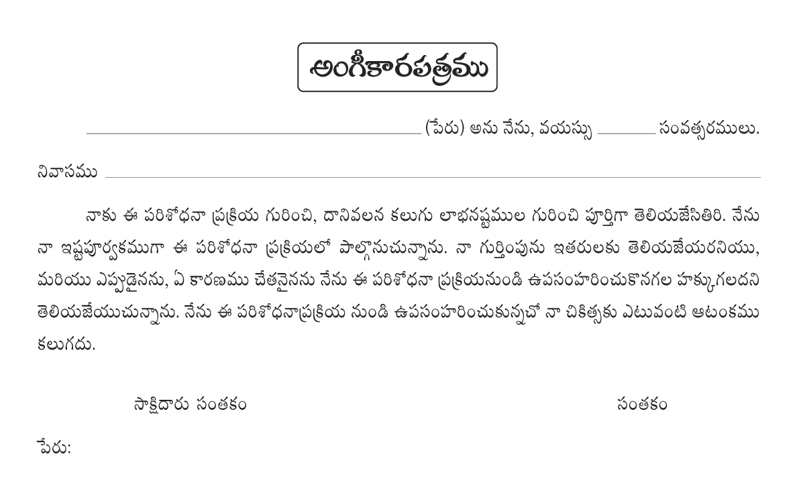

**CASE RECORD FORM (CRF)**

**ID NO:**

**Title :**

**Principal investigator :**

**Department& Institution :**

**Signature of the person collecting the data**